SHACMAN SX3315DT386配置
SHACMAN SX3315DT386
Photo for reference
此图仅供参考
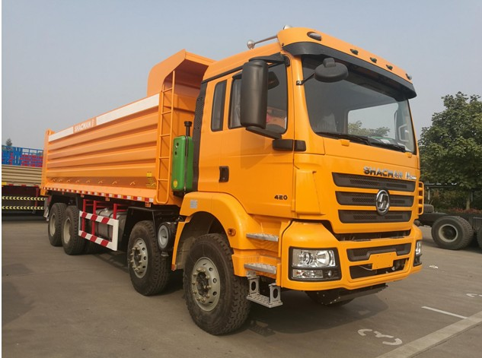

主要参数配置
Main Configuration
Platform平台 |  | F3000
Drive type驱动形式 |  | 8×4
Edition版本 |  | 加强版
Model型号 |  | SX3315DT386
Engine  发动机 | Model型号 | WP12.380E201
 | Horsepower 马力 | 380
 | Discharge排放 | 欧II
 | Gear box变速器 | 12JSD220K+QH50
Cab驾驶室 |  | 中长平顶
The highest speed最高时速 (km/h) |  | 80
Chassis(mm)车架(mm) |  | 850×300（8+7）
Wheelbase (mm)轴距(mm) |  | 1800+3775+1400
Overall dimensions of整车尺寸(mm) |  | 9700×2490×3500
Large box size大箱尺寸(mm) |  | 7600×2300×1500
Thickness 厚度(mm) |  | 底12边10
Axle speed ratio车桥速比 |  | 16T MAN双级4.769
Front axle前桥 |  | MAN 9.5T
Suspension悬架 |  | 前后多片簧  四主片+四骑马螺栓
Fuel tank油箱 |  | 400L铝合金油箱
Tires轮胎 |  | 12.00R20
Optional可选装配置

